**Portfolio**

**Zhaomin Liu（Johnny）**

**Introduction**

In this portfolio, I will introduce my original work for 2D design. I will show my work and explain the designing process and where my inspiration from.

**2D Visual Design**

**Part 1**

Let’s get start with visual design, I did 2D visual design for website, book cover and games in university. And I will focus on introducing my 2D game and Board game in this portfolio. In part 1, I will explain the art design of my 2D game called Dungeon Ghost Hunter.

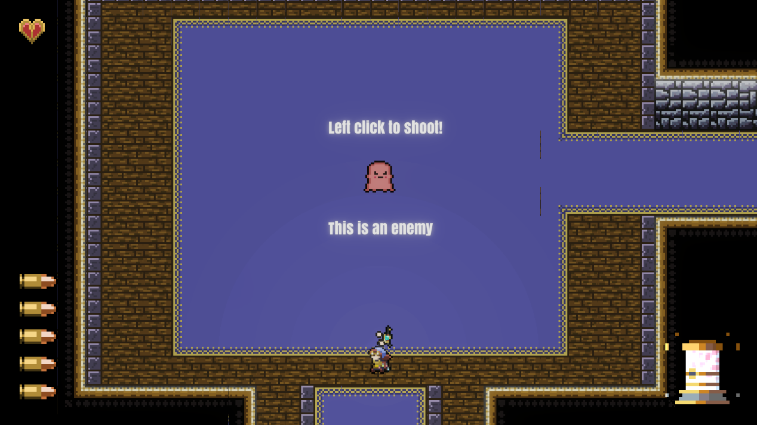

For my 2D game Dungeon Ghost Hunter, the art style inspired by the Ninja Gaiden FC version. I choose pixel graph to show my respect to those FC games, and it is simple enough to make sure players can focus on the game play rather than interfered by the complex environment. And the appearance of enemies actually inspired by another classic game, which is Pac man. But compare to those ghosts in Pac man, enemies in our game are cuter.

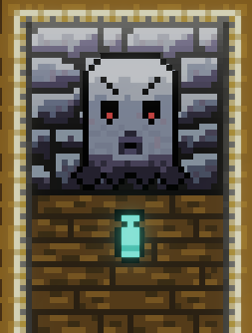

For the visual design of traps, I refer the shape of gravestones in ancient Europe, then I draw an angry face on it to remind players how danger it is. The attack mode of this trap is shooting bullets to make a fire line, the appearance of bullets from traps are same to bullets from the player. It can keep reminding the player that he/she can shoot to destroy the traps’ bullets.

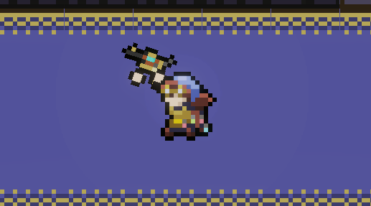

Here is our player, I draw a blue cap and a bag for him/her. For weapons he/she can use in levels, we called that alchemist’s guns. Our player will start with a pistol, it is very similar to revolver but I replaced the mag with alchemist’s container (blue part of this pistol).

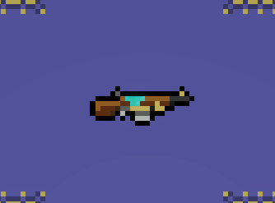

With the push of the player in levels, he/she will find a rifle with bigger mag size and higher damage. This rifle’s appearance inspired by the M1A1 cabin rifle, which was a classic WWII weapon. I changed a part of the gearbox to blue, which also represent the alchemist’s container to fit our theme.

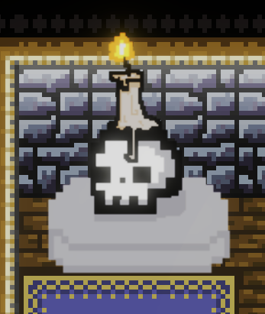

For the light in levels, I designed a skull with a candle on the top of it. All our levels are happening in a dungeon, skull and candle are both normal objects in a dungeon. This light will not break the player’s illusion of immersion and enhance the strange atmosphere. And it is obvious in levels, so the player can sometimes find useful loots near it.

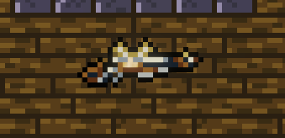

I also provide the third weapon for the player, which is a marksman rifle with high damage, low mag size, low fire rate and slow reload speed. The appearance of it inspired by the matchlock gun in 16th century.

**Part 2**

In part 2, I will mainly focus on my board game which included a lot of art source I made. I completed this board game in a 4-person group, and I was in charge of appearance design of enemies and also worked as an environment artist.

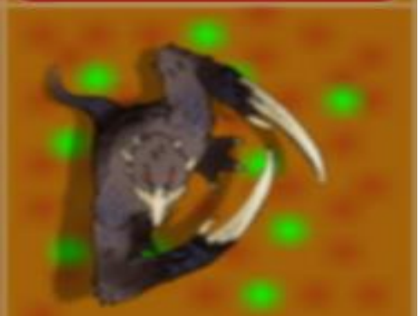

In my board game called Scary Skelly, Slasher is the first enemy that players will encounter. I draw 2 big claws and a beak for it, and all its body covered by thick brown hair. Appearance of this monster inspired three different animals: monkey, raven and mole. Its head and beak are from raven and body simulate the monkey, and it has claws like mole.

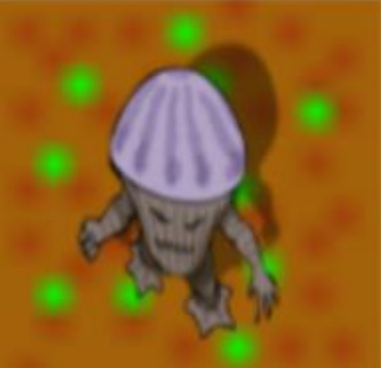

Mushroom is the most common enemy in our board game, it is a normal mush room with hands and legs. It was inspired by a kind of porcini in China, and I also refer the mushroom man from Baldur’s Gate when I was designing it.

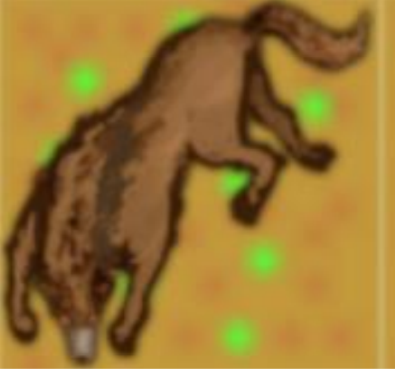

For elite enemies in our board game, I draw a wolf at first. This wolf have a smaller head than the real wolf but it has a stronger body. I didn’t choose white, grey or black hair for it, because our board game happening in a fantasy world. Brown hair is not too mismatch with a wolf and bring the fantasy element to it.

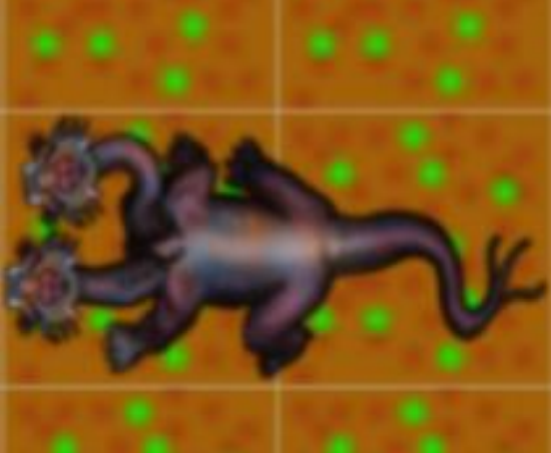

Watch Dog is another elite enemy in this board game. It is inspired by the Cerberus from Ancient Greek mythology. However, Cerberus’ appearance looks to magnificent. If I just make an enemy similar to Cerberus, players may take it as a boss. To make it fit the appearance of an elite enemy, I chose to cut one head of it and use deep red skin to replace the black hair of Cerberus from mythology.

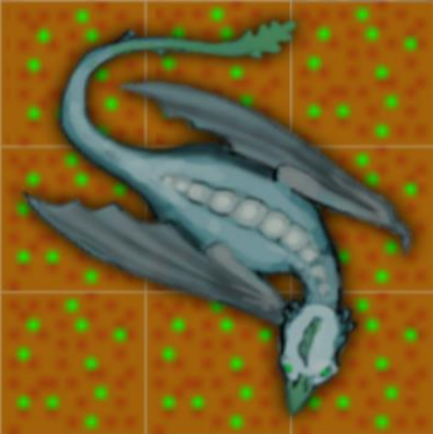

Cockatrice is a very interesting monster I made. It has bat’s wings, cock’s head, dinosaur’s body and lion’s tail. I adjusted the size carefully to make sure different elements can be combined together smoothly. To make it looks strange, I gave it the gloomy green color.

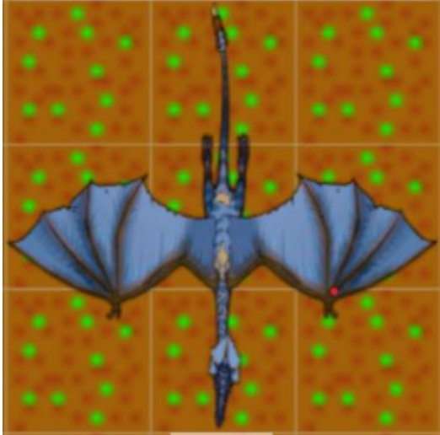

For the dragon in my board, its appearance is not come from mythology dragons. I refer the pterosaur and then created it. But I didn’t use the shape of real pterosaur’s wing for it, I chose the bird’s wings for it. Because the real pterosaur’s wing is too huge, then the body of it will looks small.

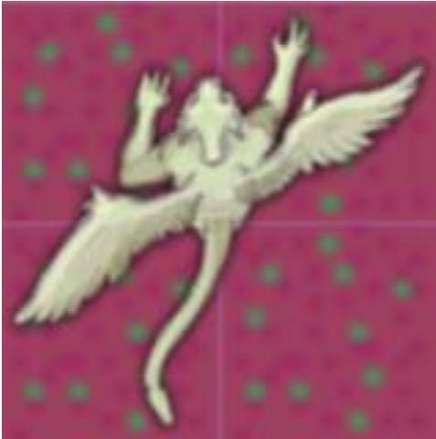

Winged beast is inspired by 2 different creatures from mythology, which are chimera and sphinx. It has human’s hands, lion’s head, bird’s wings and scorpion’s tail. But I believe that sphinx’s yellow skin or chimera’s brown hair are both not special enough, so I chose to use white hair for it. White hair can be very obvious in environment, so the player will notice it easily.

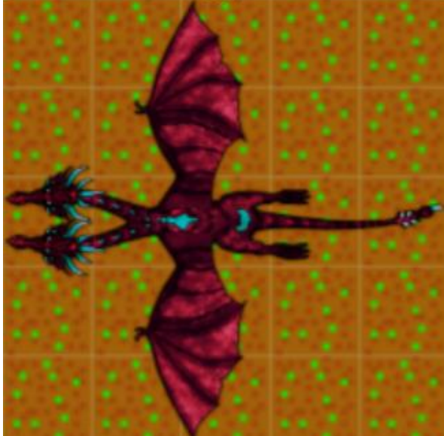

Dragon lord is the final boss of my board game. I gave it 2 heads to show the feeling of oppression. Its red and black skin means death, because red and black are both classic elements in visual design to to represent death.

**UI/UX Design**

**Main Menu**

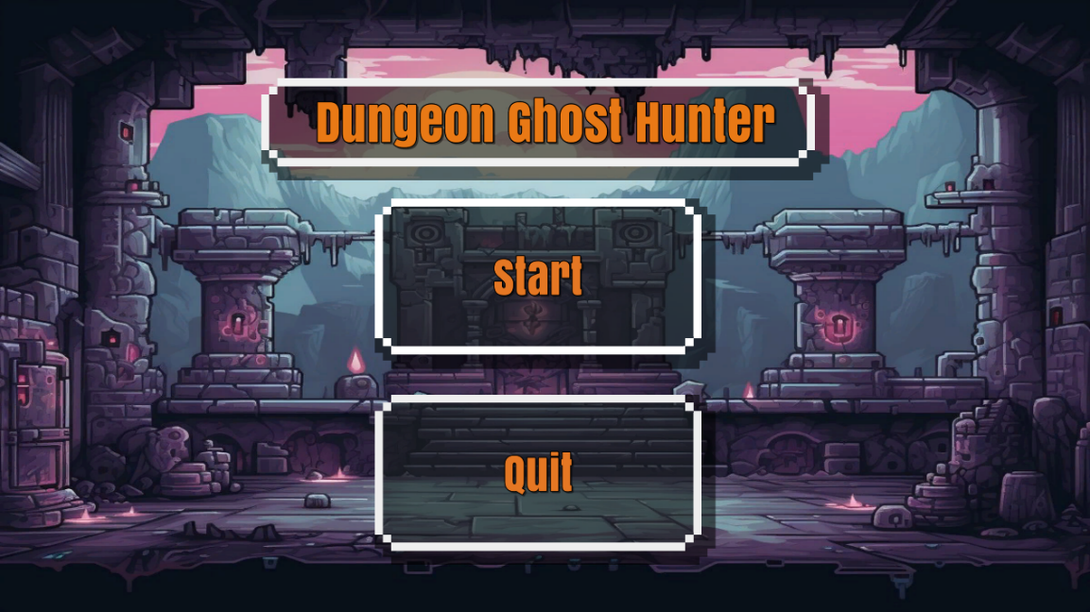

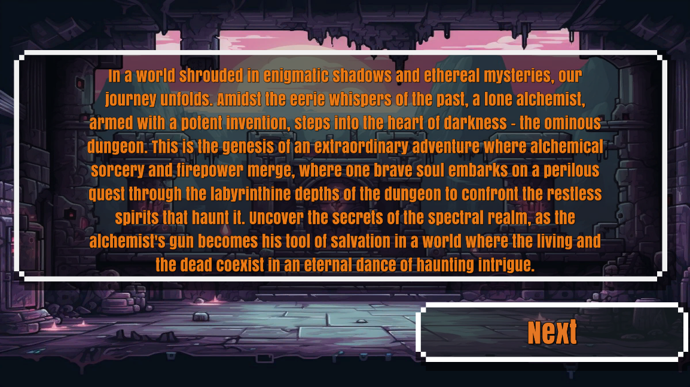

UI in Dungeon Ghost Hunter is simple but clear. All parts of UI follow the same theme, which is pixel graph in FC age. But I used higher resolution and lighter color for the main menu to make it fit the modern appreciation of beauty.

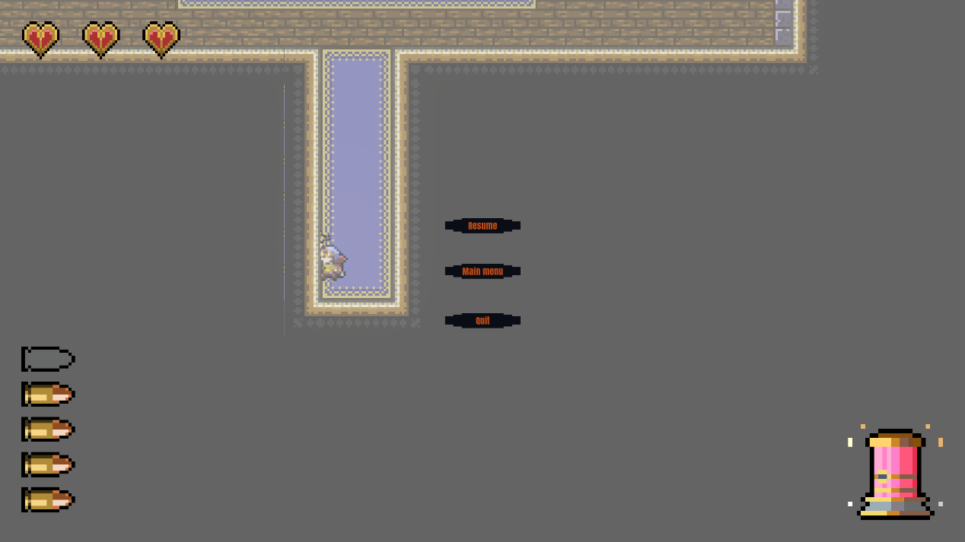

My pause menu allows the player to continue, back to main menu and quit the game directly. It is easy to understand and use, the player doesn’t need to return main menu before he/she quit the game.

**Gameplay UI**

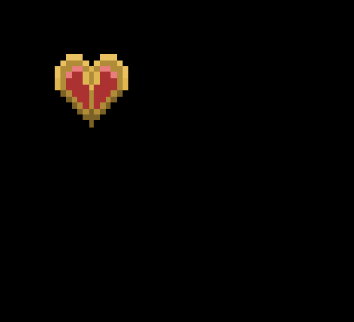

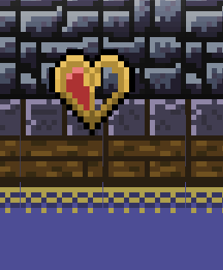

For the health bar, I didn’t make it to a bar. Because sometimes the health bar may not that clear to the player. Players may find it different to count how many hits they can take when the health represented by a bar. I choose to use hearts to represent the current health of the player, the player will lose a half of the heart for each bullet hit from enemies.

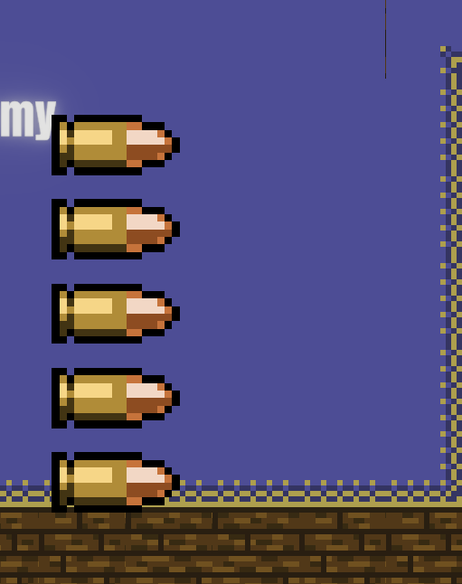

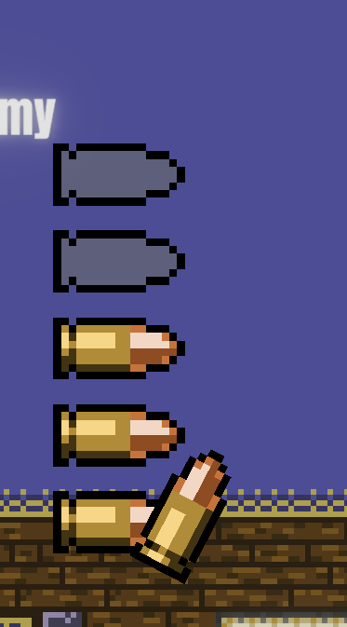

For the combat in game, I make a UI to represent how many bullets the player can shoot before reloading. For each shoot, this UI will show a bullet drop down. After its empty, the compulsory reload will be started and bullets will appear again one by one.

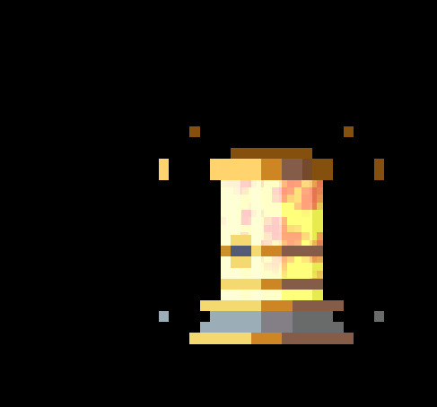

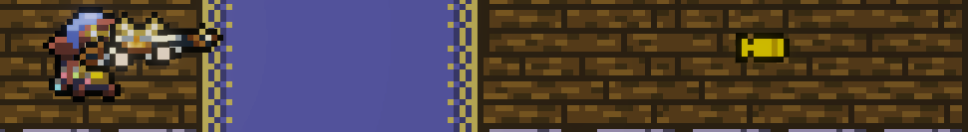

In the Dungeon Ghost Hunter, both the player and enemies can use different type of bullets. I will use the bullet color and an alchemist’s container in UI to remind the player. Yellow bullet has highest damage and velocity, it can counter yellow bullets from enemies perfectly.

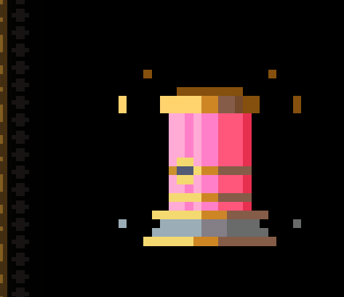

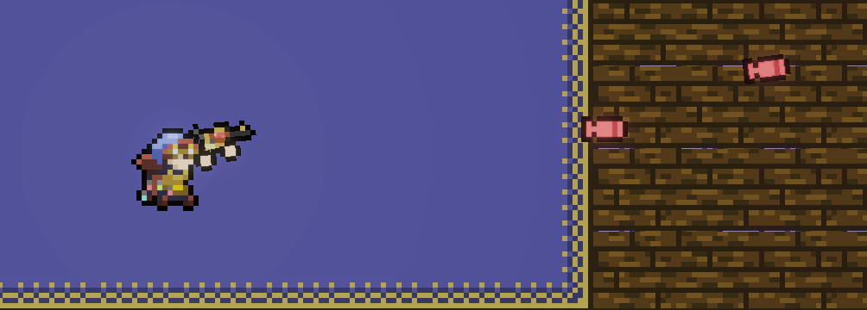

Red bullets have low damage but allow the player to reload faster, it can also destroy the red bullets from enemies. Players can switch blue and red bullets to against different enemies if they already equipped the pistol. When the player using red bullets, alchemist’s container will show full red color in UI.

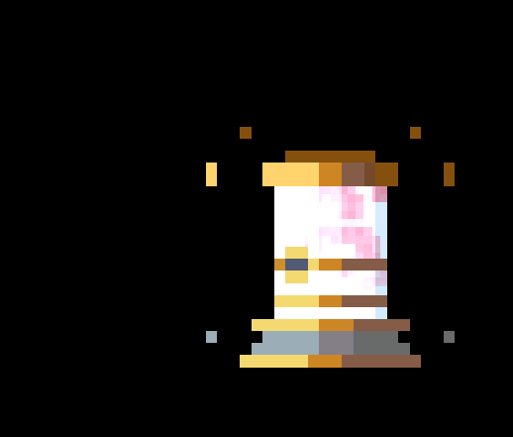

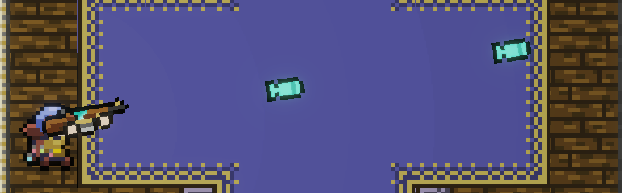

For the blue bullets, it can turn the blue bullets from enemies to many projectiles and then attack enemies. Rifle will always use blue bullets, so players can control their current ammo types easily. When the player using blue bullets, container will show light blue and pink color in UI.

**Animation/Motion Design**

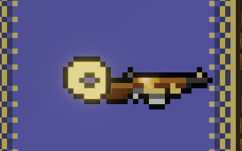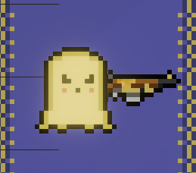

First animation I will to introduction is how enemies appear in levels. Enemies in our level will appear as a small point at first, then they will rotate and getting bigger. At the end, they will drop down to the ground and become ghosts. The enemy’s appearance inspired by the Pac man and the animation inspired by the silver teardrop in Elden Ring. This animation looks very strange and evil, so that players can understand those ghosts are enemies immediately.

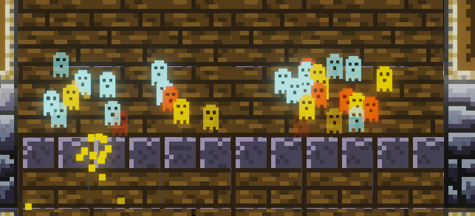

For the barrier between different levels, I make an animation that many small ghosts keep with particle effect rising from the ground and disappear after it reach the set height. This animation will keep playing as an infinity loop, it will only disappear after the player completed the current level and the next level has been unlocked.

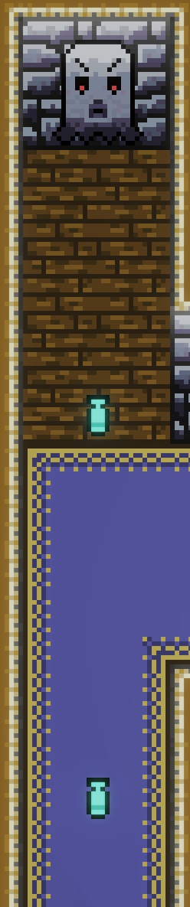

For those traps, I set the fire animation to keep all bullets at a line. And each bullet will be shot after a short interval, so the player can destory them. This animation will be kept playing until the player leave the current level.

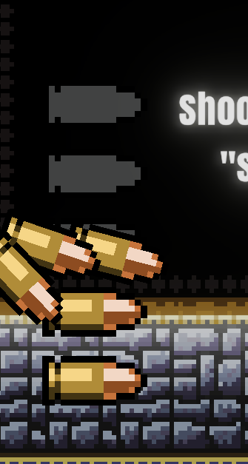

When the player shoot, reduction of bullets will be shown in UI. I make an animation to make it smooth, bullets will drop down from the mag UI when the player is shooting. I set the random dropping animation for each bullet, which is actually simulating the shell case drop down from the real gun. I made the empty mag UI by changing the current layer to other layers that already lost bullets.

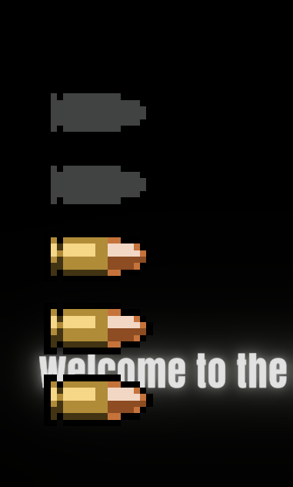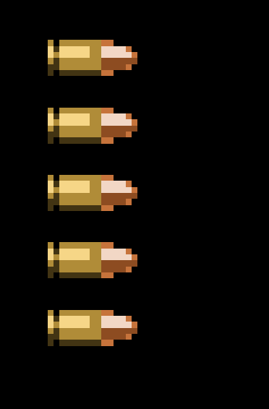

After the mag is empty, the player has to wait for reload. I made an animation to show the reloading process. Bullets will be regenerated one by one from the bottom to the top of the mag in UI, with a sound effect to remind the player. I made this by changing it to different layer to show the bullets again